Use-Case Realization Report (Requirements)
Register Volunteer Account

Issue 1.0
Revision History
Date | Issue | Description | Author

Table of Contents
1. Brief Description 4
2. Flow of Events 4
2.1 Standard Flow 4
2.2 Exceptions 4
3. Interaction Diagrams 4
3.1 Domain Collaboration Diagram: Security Management 4
4. Participating Objects 4
5. Derived Requirements 4

Use-Case Realization Report
Register Volunteer Account

Brief Description
The use case describes the new volunteer account registration of VMS system.

Flow of Events
The standard flow of events for this use case and any exceptions are described in the following subsections. See section 3.1 for an overview of the participating Actors and Domain Objects.

Standard Flow
This use case provides the user interface related functionality that will be provided to the User, as follows:
To commence using the system functions, the general public can sign for a new account as follows:
- The User clicks ‘Register’ link and the system are redirected to RegisterNewAccountScreen.
- The User is required to enter:
- Email address
- Password
- Full Name
- Date of Birth
- Gender
- Nationality
- Interests
- Language Proficiency
- Profession
- Contact
- Address
- The system will verify that the email account has not registered before and password format is valid
- After passing validation, an email notification will be sent via email address user typed in
- User is required to activate the user account via the hyperlink that was sent in the email notification from the System

Exceptions
The following exceptions have been identified:
- Invalid Password. If the new password doesn’t conform to the security format, system will prompt the format tips to assist users
- Invalid email address. If the email address is registered, system will prompt error message

Interaction Diagrams

Domain Collaboration Diagram: Security Management

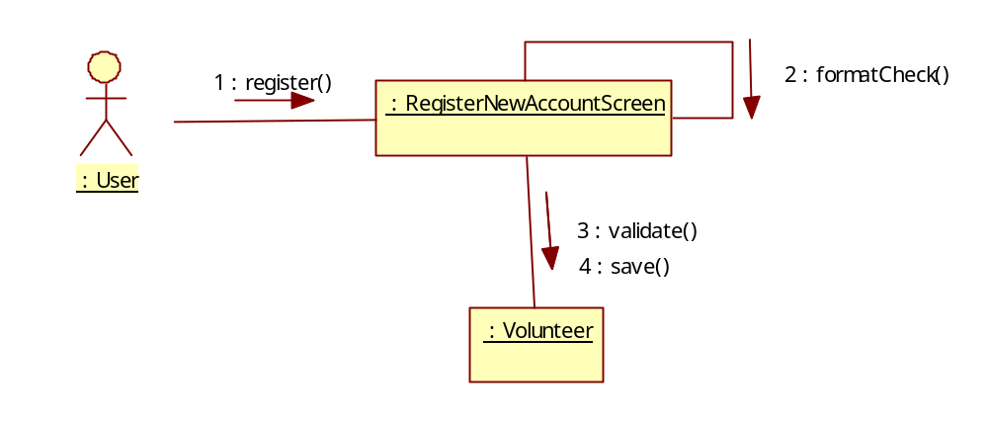

Participating Objects
:

Derived Requirements

